BIGDATA PRIVACY IN BIO-MEDICAL RESEARCH
Team Members: Prithvi yadav guni (11569548)
Srikanth Reddy Guntaka (11532833)
Sai kumar Gunda (11557081)
Rohith Reddy Ganga (11552159)
Motivation:
Biomedical studies typically consist of examining individual facts that contain character information. Inappropriate use of this information might bring about leak of delicate info that can put consumer privateers at chance. The problem of retaining client privateers has acquired increasing pursuits within the era of big data. Lots of personal privacy techniques have simply been created to shield as opposed to various strike designs. This paper assesses pertinent topics within the context of biomedical study. We go over private privacy maintaining current technology associated with (1) document association, (2) artificial facts technology, and (three) genomic facts personal privateers.
• Advancement in technology has revolutionized the field of computer wisdom with its vital part in capturing, assaying, and managing data for better monitoring, understanding, and decision timber. The use of information technology in different fields has converted the traditional approach, and now utmost of the work is backed with computers in several fields/ disciplines. The fashionability of computational technologies similar as artificial intelligence, machine literacy, data wisdom, and data mining has also increased phenomenally due to immense connection, development, and vacuity of open source technology, and data vacuity. The first similar problem considered in current work is failure/ withdrawn of the medicine after request launch. Failure of medicine after- request launch is a complex issue, and a high quantum of safety, nonsupervisory, chemical and natural data is also associated with it. In former times, utmost cases in the post-market failure of medicines have raised serious safety issues. In history, failed medicines had made an epidemic that was responsible for thousands of deaths together with profitable loss.

Significance:
- Partly HME (Home Medical Equipment) lets in a solitary form of HME operation (e.g., each enhancement or multiplication).
- Rather HME lets in every HME strategies with a limited kind of iterations and brought computational prices truly HME sustains endless range of each technique with huge computational fees.
- Safe multiparty calculation (SMC) is a tough and speedy of cryptographic strategies that permit or perhaps greater occasions to on the identical time compute competencies over their one-of-a-kind inputs without leaking their touchy information. Garbled Circuit is considerably used to gain comfy -party computation. In a Garbled circuit, the inputs of each gateway may be mapped to garbled wroth, similarly to the truth table of every gateway can be encrypted via manner of those unclear inputs.

Objectives:
- We decided on some important and useful subjects in biomedical have a look at to speak approximately applicable non-public privacy preserving present day generation. These topics consist of:
- (1) record linkage,
- (2) allocated facts evaluation,
- (3) synthetic statistics generation, and additionally
- (4) included genome opinions.
- We will create awareness on each privacy protection enhancements for every virtual health and fitness documents (EHR) and genomic statistics.
- The effects of the competitions recognized several rules in the cutting-edge genome non-public privacy safety studies. First, genomic data safety making use of perturbation-based safety techniques regularly cutting-edge too much sound, wherein useful genomic programs might not have the capability to trust worthily depend upon those noise consequences.
- Second, cryptography-based totally absolutely protection strategies for cozy cooperation or outsourcing presently clearly preserve confined genomic calculations due to their complexity.
- Third, the ethical ramifications of those protection techniques are not but easy. Therefore, more examinations of genome private privateers are vital and additionally crucial, which inspires researchers to establish present day genome privacy protection generation further to discover their honest implications.
- Medical choice aid structures need to be used. This machine is capable of help the docs to make the perfect choice. Medical choice aid machine refers to each the procedure of trying to decide or discover feasible sicknesses or sickness and the opinion reached via way of means of this procedure. The diagnostic opinion withinside the sense, it suggests both diploma of abnormality on a continuum or a form of abnormality in a classification
- Select symptoms automatic drug prediction .
Features:
We mentioned a couple of sides of massive records privateers within the context of biomedical research look at. The "large" part of records privacy is because of the truth that fitness care statistics normally consist of huge variety medical and genomic records, which might be big in size similarly to huge in size. There are some special challenges and moreover off-the-shelf equipment has problems in coping with them. For example, the scalability concerns regarding completely homomorphism safety further to included multiparty pc algorithms to govern whole genome sequencing (WGS) statistics. There are moreover difficulties in protecting the results of computation on immoderate dimensional genomic records that can speedily tire the fee variety if not allotted very cautiously. We assessed cutting element privateers-retaining improvements for file link, artificial statistics era, and genomic information evaluation. Despite of remarkable progresses, there are plenty of troubles and rising obstacles want to be dealt with and our business enterprise do not forget outstanding services to relieve privacy risks in biomedical research test need a joint effort from numerous neighborhoods (e.g., pc protection, ELSI, biomedicine, genomics, and so on).
Medical choice may be extraordinarily technical and sensitive task because of integral elements or in case of uncommon situations. The integral elements encompass stress; worn-out misdiagnosis may range from lack of expertise of docs and poor facts. Standard set of rules may work via the whole variables like triumphing situations records of scientific statistics, records of own circle of relative’s statistics and colorful elements referring to the case statistics, sheer importance of handy retired elements. Differential opinion patterns may be used to discover the presence of a fact in which more than one druthers are viable and additionally refers to encompass the seeker druthers. This machine is wishing a manner of removal or wearing facts that shrinks the chance of seeker situations to negligible situations. It includes 4 manner 1) The physician accumulates all facts approximately the instances and convey a signs and symptoms listing.2) The physician needs to make a listing of all viable reasons of signs and symptoms.3) The physician need to prioritize the listing with the aid of using that's the maximum risky viable motive of signs and symptoms placed withinside the pinnacle of the listing. 4) The physician needs to rule out or deal with the viable reasons starting with the maximum urgently risky situations.” Rule Out” withinside the feel to apply the look at machine or different scientific method. However, relies upon on which opinion is correct, If there might be no comparable opinion way casting off the opinion from the listing and the use of checks that need to have wonderful results. This may be carried out grounded at the physician’s understanding and experience. This machine is assuredly smooth to apply.

Related Work:
The definition of personal privacy is a man or woman's proper to govern get proper of access to her/his individual information, consisting of recognizing details, bio-specimen and in addition. The term discretion normally describes the protection technique of personal privateers. Making use of character's information should accomplish the necessities inside the informed permission and furthermore the facts employ settlement. The regulation and authorities’ plans can be applied to assure obedience as well as supply requirements in privateer’s safety. The Ethical, Lawful, and Social Implications (ELSI) studies are important for biomedical records privateers, which offers a latest method to biomedical research look at by means of the use of using identifying, reading similarly to tackling the ELSI of studies together with human subjects. The influences of ELSI research consist of, however aren't constrained to, the dangers and furthermore advantages associated with systematic studies take a look at, the perspectives of studies members, criminal and moreover normative factors, and so forth. For example, the benefits of maintaining discretion encompass (1) it establishes count on in among studies individuals and additionally scientists; (2) it substances elements to individuals; (3) it increases human beings' willingness in sharing data for take a look at. The important principle of study values is to make certain that no person needs to take the threat of damage because of the engagement in studies have a observe. It is furthermore vital to research participant's know-how of the benefit, risk, and the studies to be conducted. Furthermore, all individuals want to be willingly related to studies have a look at. For instance, the moral troubles regarding knowledgeable consent in genomic check encompass, however are not limited to, human beings' mindsets within the route of sharing information for primary test [11]-- [14] or extra use [15], [16], humans' information of personal privateers threat [17], [18] or studies data [19], voluntary engagement [20], and disclosure of results [21] Section 4 will definitely move over some moral ramifications of huge records privacy.
Personal privacy structure and phrases
Security of sensitive records dissemination:
Differential personal privateers (DP) have come to be the de facto criterion of privateers, which gives strong private privacy guarantee, regardless of the opponent's earlier data. DP offers a massive answer for personal privacy safety that might cowl the overall spectrum of capability information that an opponent can also additionally own.
The shape of DP is based genuinely on the belongings that the query very last consequences of a "personal" dataset want to know not alter extensively with an enhancement, deletion or adjustment of a solitary report. Otherwise, there can be a threat for risky clients to infer the identification or touchy information of a personal file. Keep in mind that DP is an alternatively stable trouble for the reason that it does no longer presume the strategies a risky character wants to apply in getting rid of those facts. DP does no longer try and limit what files can or cannot exist in a dataset. Really, the translation is unaware of (independent of) the actual facts in the dataset. To guarantee that the statistics of the question consequences do not trade appreciably with the alternate of an unmarried report, the question surrender end result is commonly distorted with the useful resource of using the addition of noise.
Architecture:
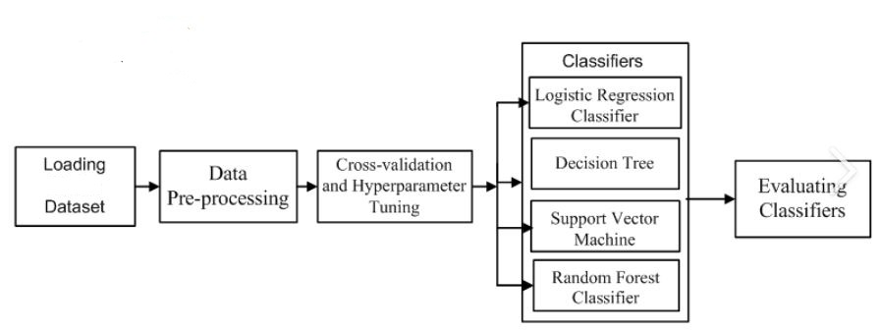Explanation:
Firstly, load the dataset and it goes for Data Pre-processing for the cross-validation and tuning purpose. Next, there are some stages like logistic regression classifier, decision tree, SVM and Random. Forest classifier which data set goes through and finally it evaluates classifiers.

MODULES

Data Preprocessing:

Pre-processing refers to the adjustments implemented to our statistics earlier than feeding it to the set of rules.

Data Preprocessing is a method this is used to transform the uncooked statistics right into easy statistics set. In different words, on every occasion the statistics is accumulated from unique reasserts it's far amassed in uncooked layout which isn't viable for the analysis.

Need of Data Preprocessing:

• For reaching higher outcomes from the implemented version in Machine Learning tasks the layout of the statistics must be in a right manner. Some specific Machine Learning version wishes data in a specific layout, for example, Random Forest set of rules does now no longer assist null values, consequently, to execute random wooded area set of rules null values must be controlled from the authentic uncooked statistics set.

• Another factor is that statistics set must be formatted in the sort of manner that multiple Machine Learning and Deep Learning algorithms are done in a single statistics set, and high-quality out of them is chosen.

Evaluation:

Machine gaining knowledge of remains a more and more more quintessential factor of our lives, whether or not we’re making use of the strategies to investigate or enterprise problems. Machine gaining knowledge of fashions ought so that it will deliver correct predictions to be able to create actual cost for a given organization.

While education a version is a key step, how the version generalizes on unseen statistics is a similarly crucial factor that must be taken into consideration in each device gaining knowledge of pipeline. We want to realize whether it definitely works and, consequently, if we are able to agree with its predictions. Could the version be simply memorizing the statistics it's far fed with, and consequently not able to make desirable predictions on destiny samples, or samples that it hasn’t visible earlier than?

In this article, we give an explanation for the strategies utilized in comparing how nicely a device gaining knowledge of version generalizes to new, formerly unseen statistics. We’ll additionally illustrate how not unusual place version assessment metrics are carried out for category and regression problems the usage of Python.

Model Evaluation Techniques:

The above troubles may be dealt with through comparing the overall performance of a device gaining knowledge of version, that is an quintessential factor of any statistics technology project. Model assessment objectives to estimate the generalization accuracy of a version on destiny (unseen/out-of-sample) statistics.

Methods for comparing a version’s overall performance are divided into 2 categories: namely, holdout and Cross-validation. Both techniques use a take a look at set (i.e statistics now no longer visible through the version) to assess version overall performance. It’s now no longer encouraged to apply the statistics we used to construct the version to assess it. This is due to the fact our version will really don't forget the complete education set and could consequently constantly are expecting the ideal label for any factor withinside the education set. This is thought as overfitting.

Holdout:

The cause of holdout assessment is to check a version on one-of-a-kind records than it became educated on. This presents an independent estimate of getting to know overall performance.
In this approach, the dataset is randomly divided into 3 subsets:
1.Training set is a subset of the dataset used to construct predictive models.
2.Validation set is a subset of the dataset used to evaluate the overall performance of the version constructed withinside the education phase. It presents a check platform for fine-tuning a version’s parameters and deciding on the satisfactory acting version. Not all modeling algorithms want a validation set.
3.Test set, or unseen records, is a subset of the dataset used to evaluate the probable destiny overall performance of a version. If a version suits to the education set a lot higher than it suits the check set, overfitting might be the cause.
The holdout technique is beneficial due to its speed, simplicity, and flexibility.
However, this approach is frequently related to excessive variability because variations withinside the education and check dataset can bring about significant variations withinside the estimate of accuracy.

Classification:
Machine getting to know is a subject of examine and is worried with algorithms that study from examples.
Classification is an assignment that calls for the usage of system getting to know algorithms that discover ways to assign a category label to examples from the hassle domain. A clean to recognize instance is classifying emails as “spam” or “now no longer spam.”
There are many one-of-a-kind forms of class obligations that you can come upon in system getting to know and specialized techniques to modeling that can be used for every.
In this tutorial, you'll find out one-of-a-kind forms of class predictive modeling in system getting to know.
After finishing this tutorial, you'll know:
- Classification predictive modeling entails assigning a category label to enter examples.
- Binary class refers to predicting one in every of instructions and multi-magnificence class entails predicting one in every of greater than instructions.
- Multi-label class entails predicting one or greater instructions for every instance and imbalanced class refers to class obligations in which the distribution of examples throughout the instructions isn't equal.

PREDICTION:
The ailment prediction is carried out and the following step is to propose tablets to the user. The ailment symptom dataset and the drug dataset has been merged the use of pandas library in python. The drug dataset includes five columns which can be ailment, drug call, review, score, and beneficial matter. We wished common score of a specific tablet as there had been fifty-two one-of-a-kind sicknesses and every ailment had more than one tablets. The common score may be calculated the use of the weighted common approach among the score column and the beneficial matter column. There is lot of similarity among the weighted mathematics and normal mathematics mean (common) besides that withinside the weighted common a few records factors are greater to make contributions to the equation and in the normal approach every records factors make contributions similarly for the very last common. This is all carried out the use of pandas in python and a brand-new dataset is created with the ailment which are gift withinside the first dataset and the common score calculated from the medicine dataset in conjunction with the call of the medicine. This dataset might be covered withinside the utility and pinnacle five rated tablets might be proposed in a brand new pastime withinside the android in conjunction with its reviews.
Work Flow Diagrams:
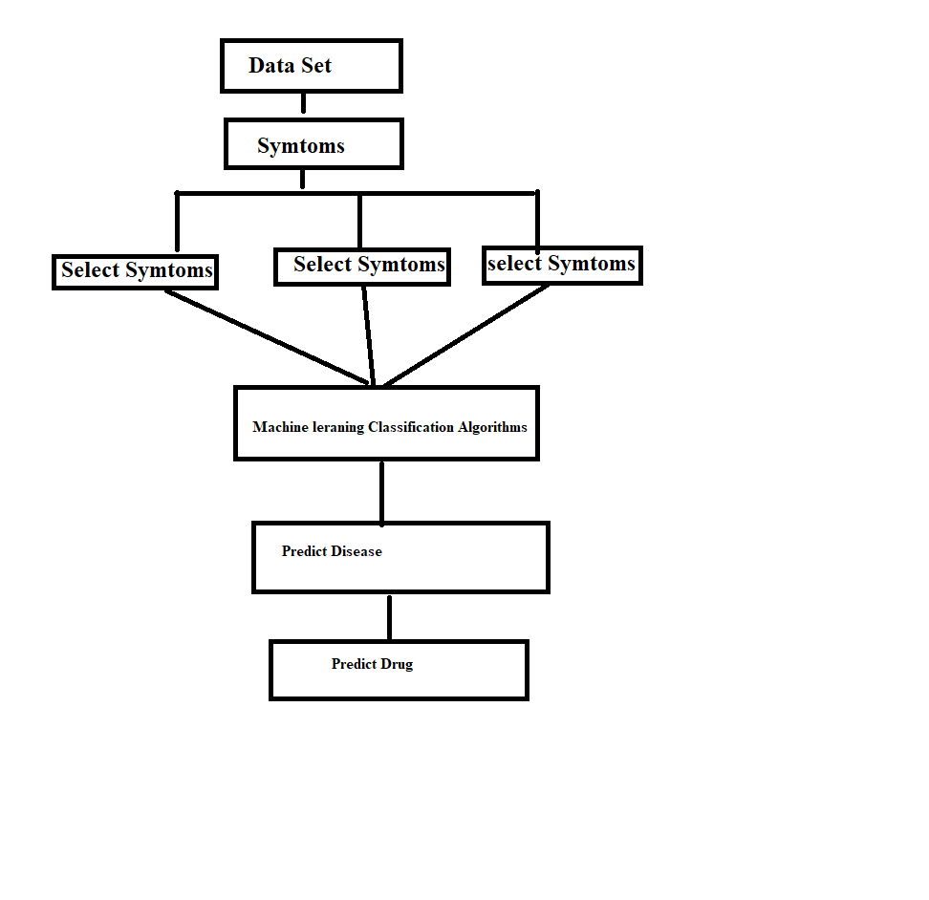
Explanation:
Dataset contains the all sets of symptoms for the disease that are trained. We just need to input the symptoms like symptom1,symptom2,symptom3. Based on the symptoms, Machine Learning Classification Algorithm predicts the disease and finally predicts the drug.
Dataset:
The big data of information technology has provided the opportunity to store and analyze the massive amounts of information more effectively. Novel technology in computation and development of new and useful machine learning algorithms are playing a pivotal role in the application of information technology to resolve challenging problems of different fields. Massive data associated with all drugs such as biological, chemical, and clinical are available in different databases and literature. Information availability is the key to the use of computational methods to address the problems, and in most cases, clean data is used and required to develop machine learning models. This information of all drugs can be used to design a new method to predict future failure of compounds which are currently in the drug design pipeline or thought to be developed as a drug even prior to synthesis of or even before conducting any laboratory experiment.
Here I am Taking The Data is Medical Data Set for Different Symptoms and Select Sympotms Get Disease And Drug.
Dataset:
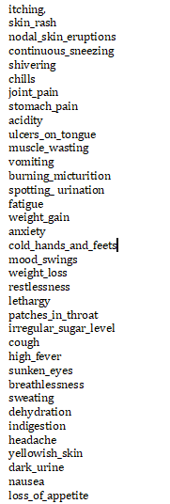
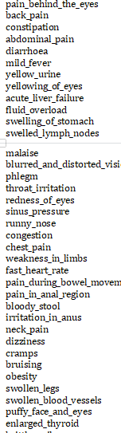

Training Dataset:

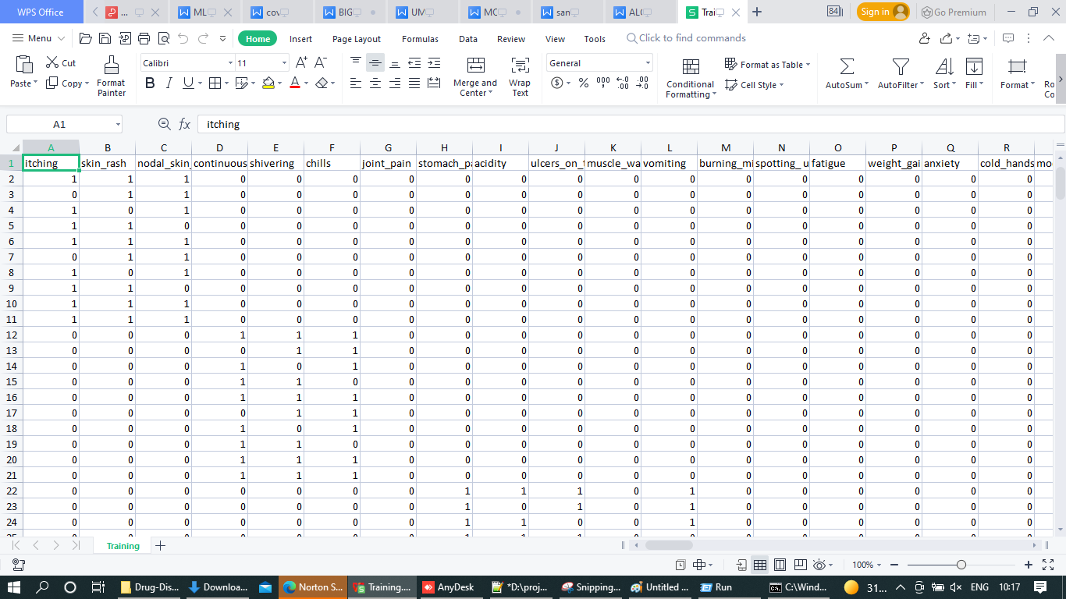

Testing Dataset:

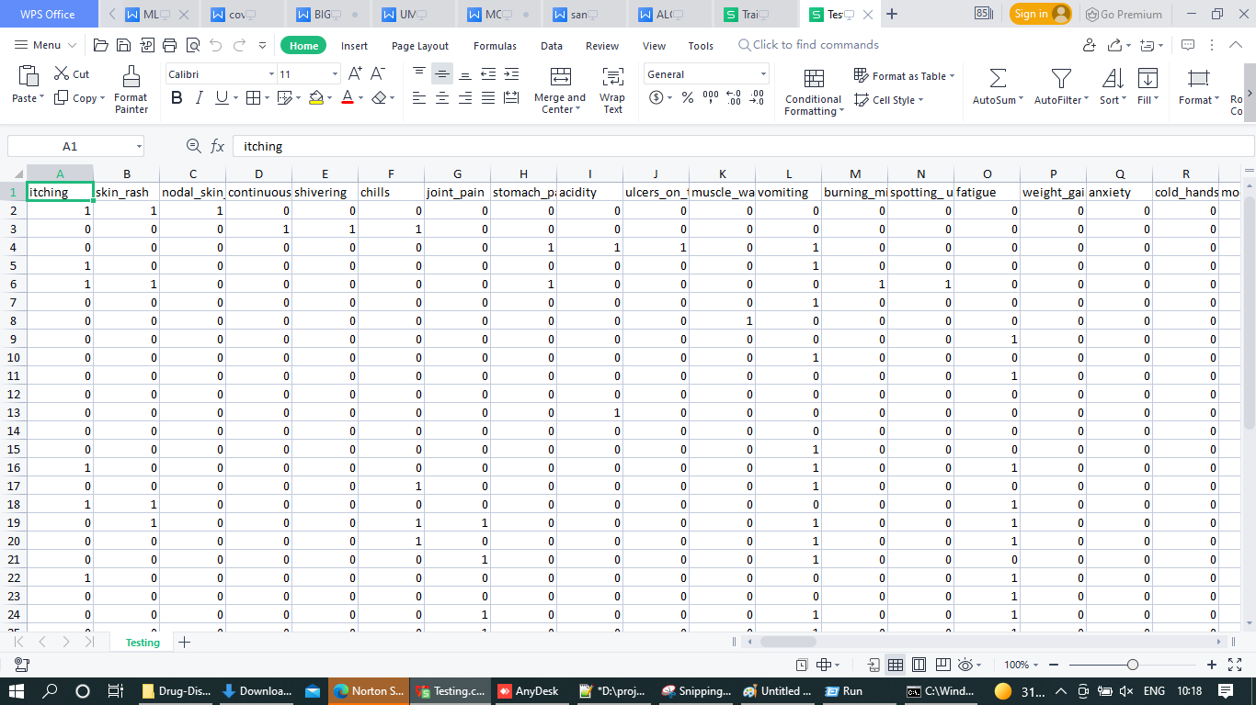

Data collection stage this is the plain initial step. It consists of collecting records from wonderful belongings in distinct patterns. From a protection and protection attitude, safeguarding massive health records era is a vital need from the preliminary phase of the lifecycle. As a cease result, it's far vital to accumulate information from relied on resources, protect customer private privateers (there need to be no effort to apprehend the unique patients in the database) and additionally make certain that this diploma is safeguarded and secured. Without a doubt, some completely grown safety capabilities should be used to make certain that all information and moreover information systems are secured from unauthorized get entry to, disclosure, alteration, replication, diversion, harm, loss, abuse or robbery.
Data alternate diploma Once the records is to be had, the number one step is to clean out and understand the facts based absolutely mostly on their structure and do any shape of essential enhancements if you need to perform realistic assessment. A lot extra typically, statistics filtering machine, enrichment and exchange are hard to decorate the immoderate wonderful of the records earlier of analytics or modeling segment further to dispose of or certainly cope with sound, outliers, lacking values, replicate facts times, and plenty of others. On the opportunity side, the accrued facts might probable have sensitive data that makes extraordinarily critical to take ok precautions for the duration of statistics makeover further to retaining. In order to guarantee the safety of the amassed data, the information need to live isolated and secured thru preserving get right of get entry to to-level safety and additionally accessibility control (the use of a whole list of listing net web sites and additionally statistics assets as a outstanding database for individual qualifications, software logon layouts, password regulations and moreover customer setups) [22], and defining a few security techniques like facts anonymization method, permutation, and furthermore records partitioning.-
Input Style plays a crucial duty within the life cycle of software increase, it calls for especially aware interest of builders. The input format is to feed records to the software program software as specific as feasible. So inputs are alleged to be designed correctly to make certain that the mistakes taking vicinity at the same time as feeding are reduced. According to Software Engineering Concepts, the enter bureaucracy or shows are created to deliver to have a reputation manage over the enter drawback, range similarly to other associated validations.
This device has input monitors in nearly all the modules. Error messages are hooked up to signal the client every time he dedicates some mistakes and furthermore guides him in nicely to ensure that invalid access isn’t made. Let us see deeply regarding this beneath thing layout.
Input fashion is the manner of remodeling the purchaser superior enter proper into a laptop-based totally layout. The purpose of the input layout is to make the facts front rational in addition to without mistakes. The mistakes is within the input are managed by using the usage of manner of the enter format. The software program has in reality been advanced in sincere way. The kinds have virtually been created in this sort of manner at a few degrees within the processing the arrow is positioned within the function in which want to be entered. The person is also given within an alternative to select a proper input from numerous options linked to the region particularly instances.

Graph:
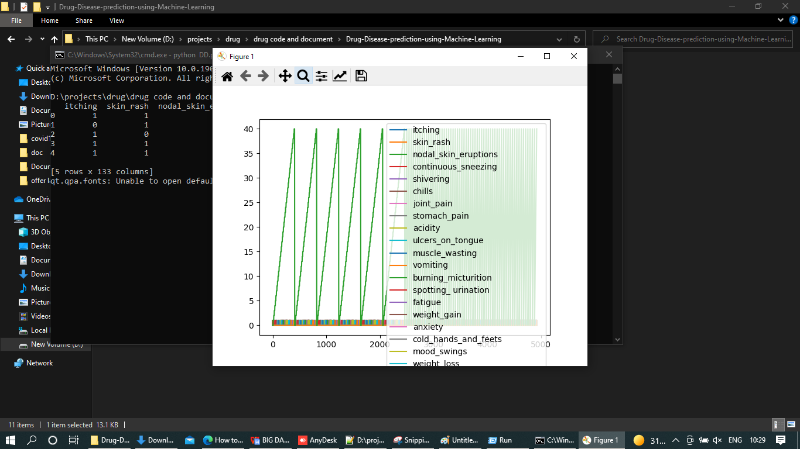
Algorithms:
Support Vector Machine:
“Support Vector Machine” (SVM) is a supervised gadget getting to know set of rules which may be used for each category and regression challenges. However, it's miles in the main utilized in category problems. In this set of rules, we plot every facts object as a factor in n-dimensional area (wherein n is range of functions you have) with the price of every function being the price of a specific coordinate. Then, we carry out category via way of means of locating the hyper-aircraft that differentiate the 2 instructions very well (study the underneath snapshot). Support Vectors are surely the co-ordinates of character observation. Support Vector Machine is a frontier which satisfactory segregates the 2 instructions (hyper-aircraft/ line). More formally, a aid vector gadget constructs a hyper aircraft or set of hyper planes in a high- or infinite-dimensional area, which may be used for category, regression, or different obligations like outliers detection. Intuitively, an awesome separation is completed via way of means of the hyper aircraft that has the most important distance to the closest training-facts factor of any class (so-known as purposeful margin), on the grounds that in preferred the bigger the margin the decrease the generalization blunders of the classifier. Whereas the unique trouble can be said in a finite dimensional area, it frequently takes place that the units to discriminate aren't linearly separable in that area. For this reason, it turned into proposed that the unique finite-dimensional area be mapped into a miles higher-dimensional area, possibly making the separation less difficult in that area.
Pseudo Code :
def SVC1():
global svcdis
from sklearn.svm import SVC
svm = SVC() # empty model of the SVM
lf = svm.fit(X, y)
# Accurecy Calculating--------------------------------------------------------------- from sklearn.metrics import accuracy_score
y_pred=svm.predict(X_test)
print(accuracy_score(y_test, y_pred))
print(accuracy_score(y_test, y_pred,normalize=False))
Psymptoms1 = [Symptom1.get(),Symptom2.get(),Symptom3.get(),Symptom4.get(),Symptom5.get()]
for k in range(0,len(l1)):
for z in psymptoms1:
if(z==l1[k]):
l2[k]=1
Inputtest1 = [l2]
predict = clf6.predict(inputtest1)
Predicted1=predict[0]
h='no'
for a in range(0,len(disease)):
if(predicted == a):
H1='yes'
break
if (h1=='yes'):
T4.delete("1.0", END)
svcdisease = disease[a]
T4.insert(END, disease[a])
else:
T4.delete("1.0", END)
T4.insert(END, "Not Found")

Results:
Enter the Name of patient and enter the symptoms of the patient to prediction the disease. And then click on algorithm from which you want to predict.
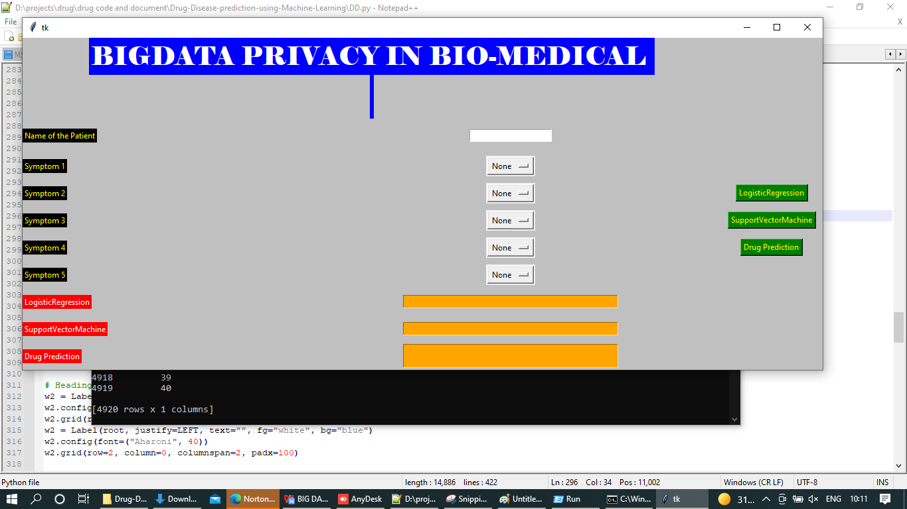
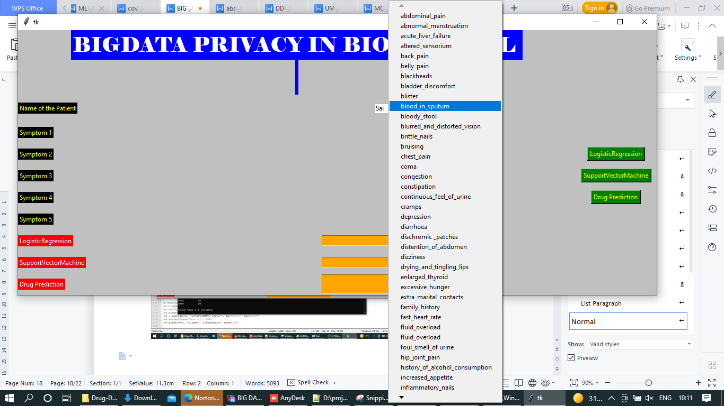
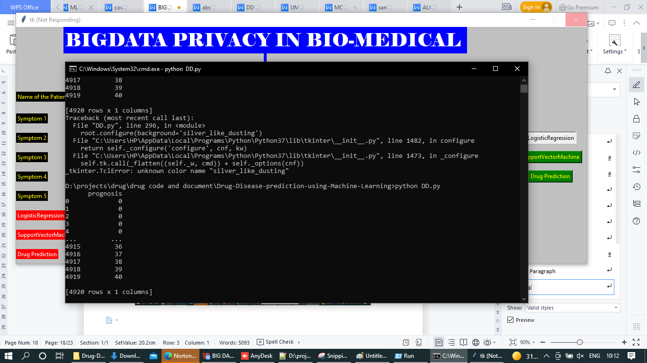

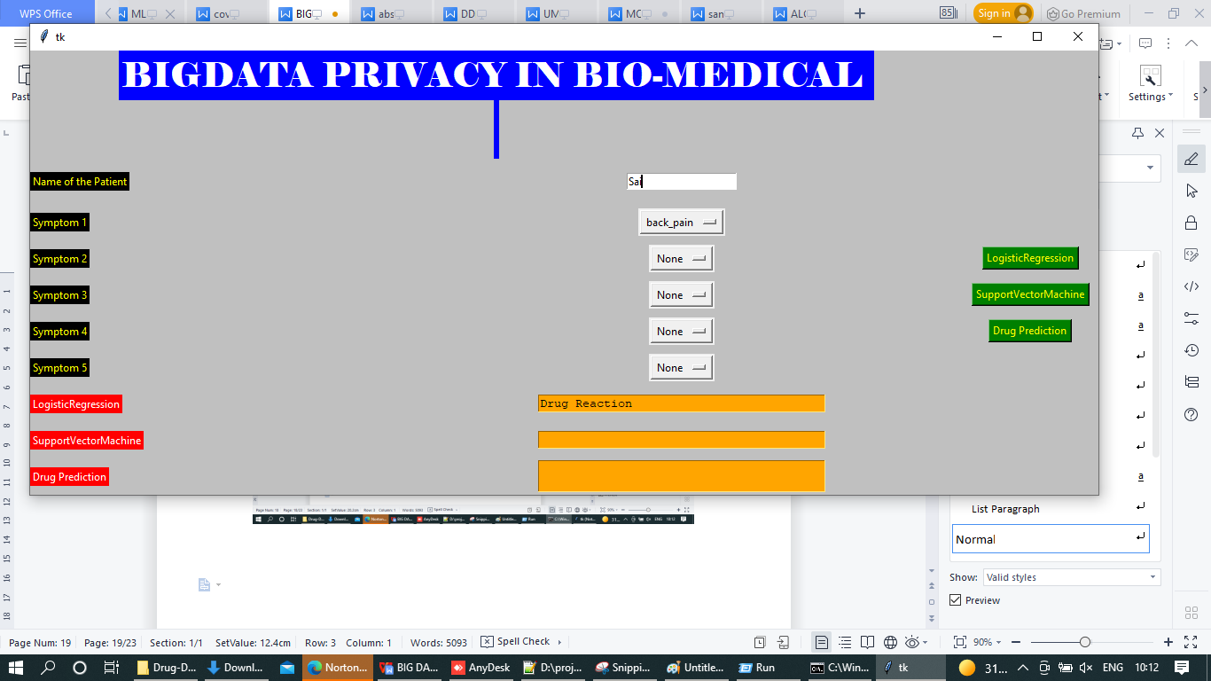
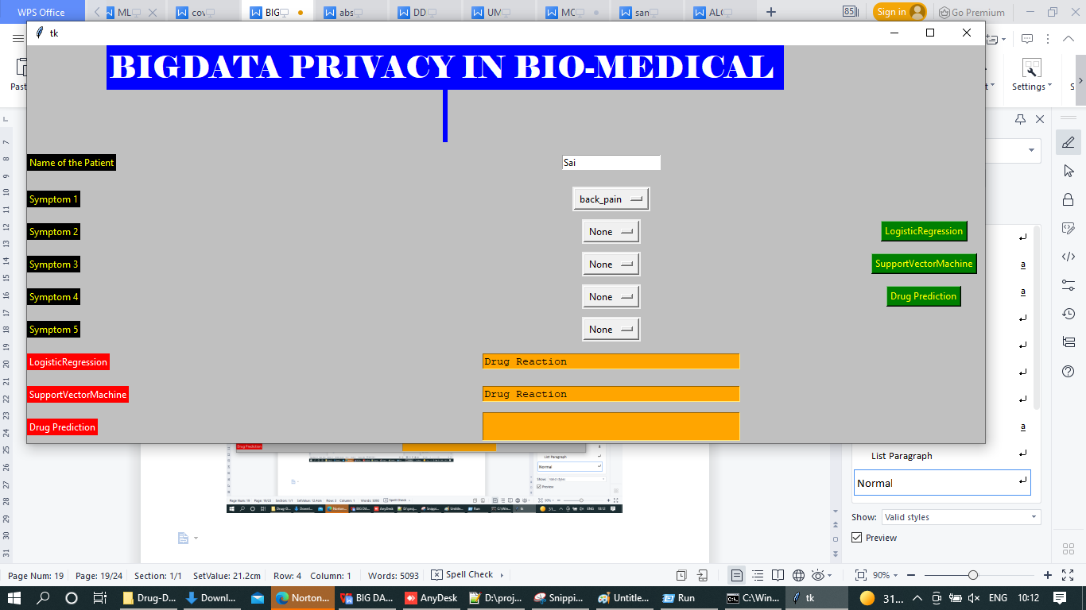
From the above figure for given symptoms it predicted Hypertension by using Logistic regression
Now test for SVM also.
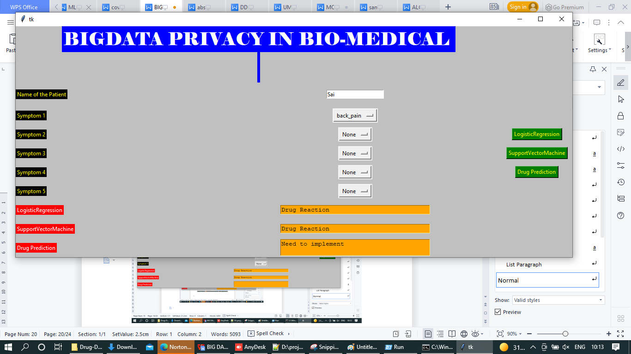

Output Explanation:
When we run the python code through CMD, we get the graph of the dataset, then the GUI loads, where we must input the name of the person(patient) first then you can select 1 if you are having only one symptom or more if you have multiple symptoms up-to 5. And based on the symptoms the algorithms predict the Disease and then predicts the drug according to that Disease.
Symptoms for Diabetes:
Blurred & Distorted Vision,
Obesity,
Excessive hunger
Polyuria
Increased appetite
Symptoms for Hypertension:
Lack of concentration, Unsteadiness,
Diziness, chest pain,
Diagrams:
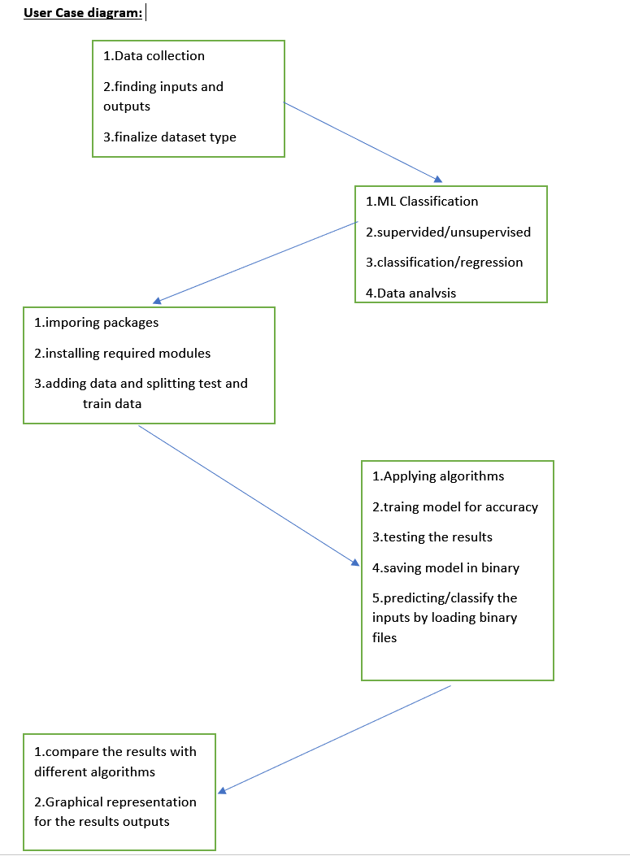

Class Diagram:

Use Case Diagram:
Sequence Diagram:

Collaboration Diagram:

Project Management System:
Implementation Status Report:
Description:
Modification is the contemporary famous for the worldwide fitness care concern. In fact, digitization of nicely being and additionally affected man or woman statistics is assignment a massive and essential shift in the clinical, walking and organization designs and usually in the world of monetary device for the foreseeable future. This exchange is being stimulated via using growing older populations and additionally way of lifestyles changes; the spreading of software program utility applications and additionally cell phones; contemporary-day remedy alternatives; greater focus on care excessive fantastic and price; and proof-based remedy in area of subjective scientific selections-- all of which is probably resulting in provide excellent possibilities for supporting expert preference, improving health care transport, manage as well as plan manufacturing, shriveling scenario, monitoring horrific sports, and improving remedy for illnesses impacting several organ structures. We compare a few interesting, related works further to provide risks to the massive health and properly-being statistics safety further to a few extra present-day era to treatment those dangers. Then, we attention at the large statistics privacy subject in hospital treatment, thru bringing up several rules and additionally pointers superior through using special regulative our bodies similarly to explaining some possible strategies used to ensure the person's personal privacy. After that, we provide a few cautioned techniques and strategies which have been referred to in the literary works to address safety in addition to privateer’s threats in fitness care at the same time as recognizing their constraints. Finally, we provide very last mind and moreover highlight the destiny instructions.
S.No | Name | Responsibility | Contributions
1 | Prithvi Yadav Guni | Creation and managing the dataset. Data preprocessing. | 25%
2 | Srikanth Reddy Guntaka | Algorithms, Testing & Training | 25%
3 | Sai Kumar Gunda | Execution and GUI implementation. | 25%
4 | Rohith Reddy Ganga | Code implementation, Documentation. | 25%

References:
[1] Burg hard C. Big data and analytics key to accountable care success. Framingham IDC Health Insights; 2012.
[2] Fenandez L, O'Connor M. Weaver V. Big data, bigger outcomes. J AHIMA
2012,83 38-42
[3] David Holding, Mac, CISSP Health Information at Risk Successful Strategies for
Healthcare Security and Privacy. Healthcare IT Program Of cue Incel Corporation,
white paper. 2011
[4] South Teesside NHS Foundation Trust Harnessing analytics for strategic planning, operational decision making +and end-to-end improvements in patient care
IBM Smarter Planet brief 2013.
[5] UNC Health Care relies on analytics to better manage medical data and improve patient care. IBM Press release. 2013.
[6] Indians Health Information Exchange http://www.ikie org Accessed 24 Mar 2016:
Transforming healthcare through big data, strategies for leveraging big data in the healthcare industry. Institute for Health 2013.
[7] Groves Kayani B. Knott D, Fukien SV. The big data revolution.
accelerating value and innovation 2013 healthcare,
[8] WHO. Mobile phones help people with diabetes to manage fasting and feasting during Ramadan. Features 2014
[9] Sophia Genetics Product & Technology Overviews 2014

